**DAILY ONLINE ACTIVITIES SUMMARY**

|  |  |  |  |  |  |
| --- | --- | --- | --- | --- | --- |
| **Date:** | | **03/07/2020** | **Name:** | **JASLINE SHARON TAURO** | |
| **Sem & Sec** | | **4th sem, A Section** | **USN:** | **4AL18CS029** | |
| **Online Test Summary** | | | | | |
| **Subject** | **-------** | | | | |
| **Max. Marks** | **--** | | **Score** | **--** | |
| **Certification Course Summary** | | | | | |
| **Course** | | CLOUD SUPPORT ASSOCIATE | | | |
| **Certificate Provider** | | **AWS Educate** | **Duration** | | **4 hrs.** |
| **Coding Challenges** | | | | | |
| **Problem Statement: --------** | | | | | |
| **Status: ---------** | | | | | |
| **Uploaded the report in GitHub** | | | **YES** | | |
| **If yes Repository name** | | | ----- | | |
| **Uploaded the report in slack** | | | **YES** | | |

Online Test Details: (Attach the snapshot and briefly write the report for the same)

Certification Course Details: (Attach the snapshot and briefly write the report for the same)

Coding Challenges Details: (Attach the snapshot and briefly write the report for the same)

CERTIFICATION COURSE DETAILS:

Today I have continued the course “Cloud Support Associate” by AWS Educate. In this course today I learnt about ‘Introduction of cloud support associate ’and ‘Platforms’. Today I have completed two modules of this course. And I have also completed the assessment of this module.

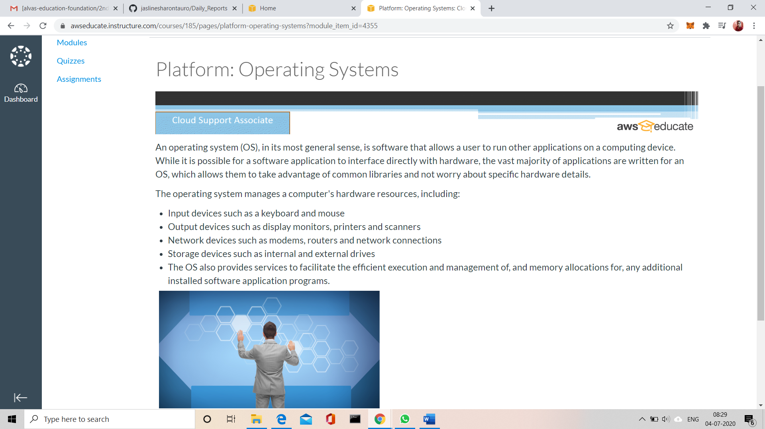

## 

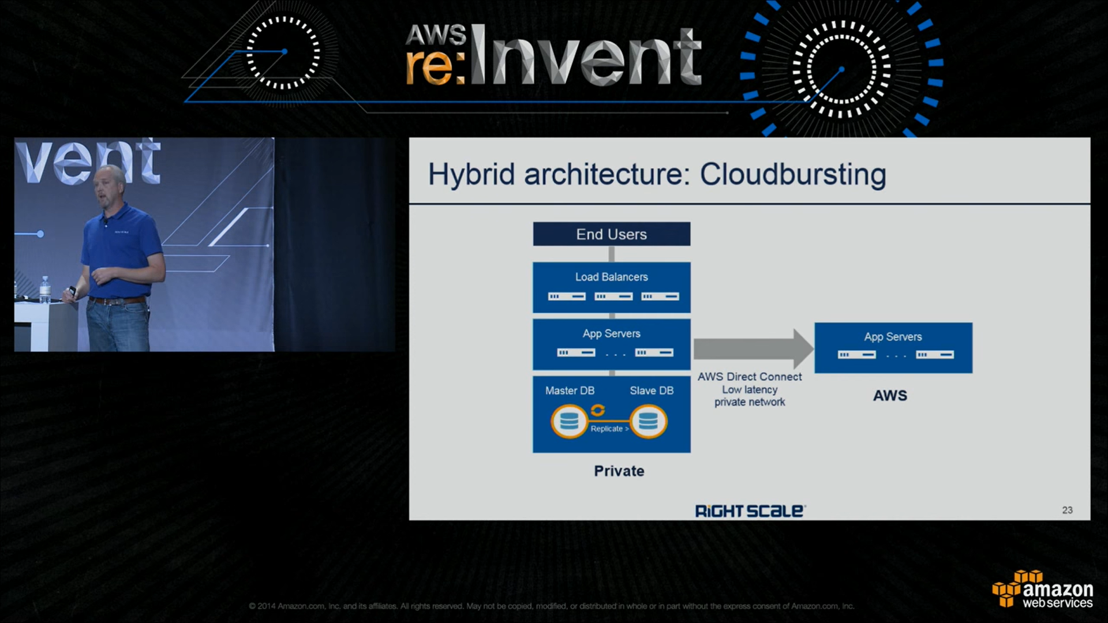

**WEBINAR DEAILS:**

**Today I attended a webinar on “Loops and conditional statements, Array” by Assistant professor Ms. Megha D. Hegde. The session was very interesting. There was a quiz conducted based on the webinar, I scored 20/30.**

